*Heaven’s light is our guide.*

*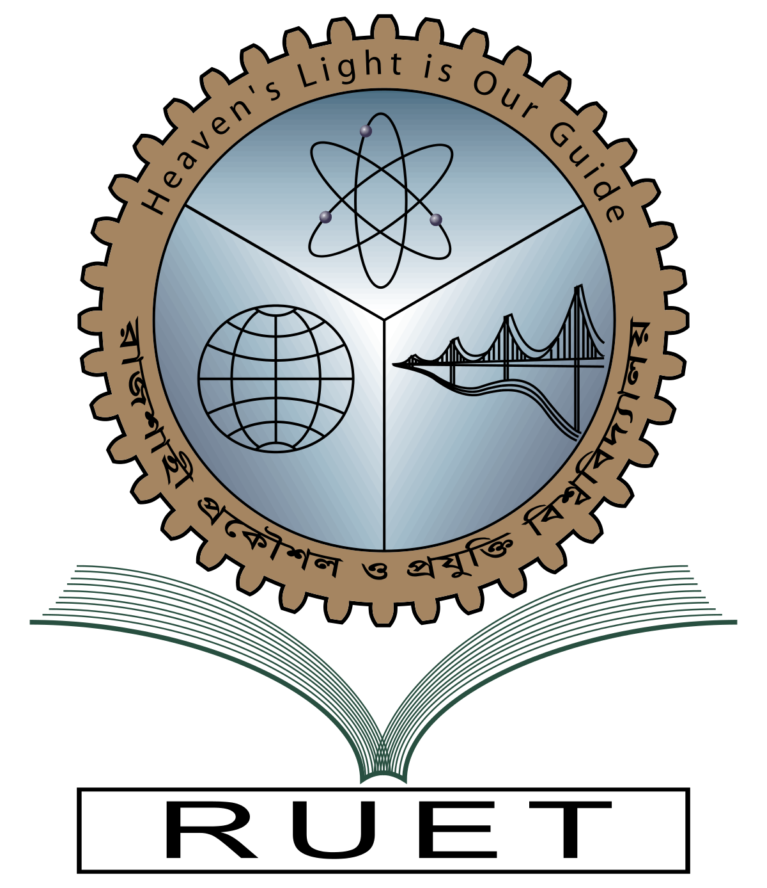***Rajshahi University of Engineering and Technology**

**

**Department of Electrical & Electronic Engineering**

**Course no.** EEE3212

**Course title:** Power Sytem I Sessional

**Experiment no.** 06

**Experiment name:** Generate an algorithm and write a program on load flow study of a given power system using Newton Raphson method

**Date of experiment:** January 13,2023

**Date of submission:** January 22, 2023

|  |  |
| --- | --- |
| **Submitted to:** | **Submitted by:** |
| **Md. Nuhi-Alamin**  **Lecturer**  Dept. of Electrical & Electronic Engineering,  Rajshahi University of Engineering and Technology. | **Ashraf Al- Khalique**  **Roll:** 1801171  **Session:** 2018-2019  Dept. of Electrical & Electronic Engineering,  Rajshahi University of Engineering and Technology. |